theorytheorytheorytheorytheory

1
Interpretation: The affirmative must defend a just government as a general principle, not specify a subset
CCC Capital Community College [a nonprofit 501 c-3 organization that supports scholarships, faculty development, and curriculum innovation], “Articles, Determiners, and Quantifiers”, http://grammar.ccc.commnet.edu/grammar/determiners/determiners.htm#articles AG
The three articles — a, an, the — are a kind of adjective. The is called the definite article because it usually precedes a specific or previously mentioned noun; a and an are called indefinite articles because they are used to refer to something in a less specific manner (an unspecified count noun). These words are also listed among the noun markers or determiners because they are almost invariably followed by a noun (or something else acting as a noun). caution CAUTION! Even after you learn all the principles behind the use of these articles, you will find an abundance of situations where choosing the correct article or choosing whether to use one or not will prove chancy. Icy highways are dangerous. The icy highways are dangerous. And both are correct. The is used with specific nouns. The is required when the noun it refers to represents something that is one of a kind: The moon circles the earth. The is required when the noun it refers to represents something in the abstract: The United States has encouraged the use of the private automobile as opposed to the use of public transit. The is required when the noun it refers to represents something named earlier in the text. (See below..) If you would like help with the distinction between count and non-count nouns, please refer to Count and Non-Count Nouns. We use a before singular count-nouns that begin with consonants (a cow, a barn, a sheep); we use an before singular count-nouns that begin with vowels or vowel-like sounds (an apple, an urban blight, an open door). Words that begin with an h sound often require an a (as in a horse, a history book, a hotel), but if an h-word begins with an actual vowel sound, use an an (as in an hour, an honor). We would say a useful device and a union matter because the u of those words actually sounds like yoo (as opposed, say, to the u of an ugly incident). The same is true of a European and a Euro (because of that consonantal "Yoo" sound). We would say a once-in-a-lifetime experience or a one-time hero because the words once and one begin with a w sound (as if they were spelled wuntz and won). Merriam-Webster's Dictionary says that we can use an before an h- word that begins with an unstressed syllable. Thus, we might say an hisTORical moment, but we would say a HIStory book. Many writers would call that an affectation and prefer that we say a historical, but apparently, this choice is a matter of personal taste. For help on using articles with abbreviations and acronyms (a or an FBI agent?), see the section on Abbreviations. First and subsequent reference: When we first refer to something in written text, we often use an indefinite article to modify it. A newspaper has an obligation to seek out and tell the truth. In a subsequent reference to this newspaper, however, we will use the definite article: There are situations, however, when the newspaper must determine whether the public's safety is jeopardized by knowing the truth. Another example: "I'd like a glass of orange juice, please," John said. "I put the glass of juice on the counter already," Sheila replied. Exception: When a modifier appears between the article and the noun, the subsequent article will continue to be indefinite: "I'd like a big glass of orange juice, please," John said. "I put a big glass of juice on the counter already," Sheila replied. Generic reference: We can refer to something in a generic way by using any of the three articles. We can do the same thing by omitting the article altogether. A beagle makes a great hunting dog and family companion. An airedale is sometimes a rather skittish animal. The golden retriever is a marvelous pet for children. Irish setters are not the highly intelligent animals they used to be. The difference between the generic indefinite pronoun and the normal indefinite pronoun is that the latter refers to any of that class ("I want to buy a beagle, and any old beagle will do.") whereas the former (see beagle sentence) refers to all members of that class

Standards
- Precision outweighs - anything outside the res is arbitrary and unpredictable because the topic determines prep, not being bound by it lets them jettison any word. Aff arguments are non-unique since a] it relies on semantics to convey those messages and b] pragmatics can be discussed anytime while we only have 2 months to discuss the wording of this unique topic
- Limits and Ground - decimates clash by exploding limits to infinite governments with infinite possible interps of what constitutes a just one, each with different political climates, economies, and human rights problems which makes contesting the aff with unifying neg ground impossible and means they can always pick the most aff skewed country. Means a] we always have an irreciprocal research burden since we have to prepare for infinite combinations of affs b] our arguments aren’t researched in depth worsening clash and c] worsens small school accessibility by infinitely multiplying their caselist
- TVA – read your aff as an advantage under whole res – we still get your content education and sufficient aff ground by switching up aff advantages, frameworks, implementation, etc. The existence of pics doesn’t answer this - a] 1ar theory checks b] plans incentivize more generic cheaty counterplans since nothing else links and c] preemptive abuse doesn’t justify actual abuse or they’ll read 50 a prioris to answer 40 condo pics
- Reasons that specification is good are an independent shell for us - if specifying a just government was good, you should’ve also specified strikes, workers, etc

2
Interpretation: if the affirmative is breaking a new aff, they must disclose the plan text, advantage areas, and standard text to the negative on a mutually agreed platform at least 30 minutes prior to the round if requested by their opponent
Violation: [screenshot]
The standard is neg prep—4 minutes of prep is not enough to put together a coherent 1nc or update generics—30 minutes is necessary to learn a little about the affirmative and piece together a coherent strategy and do research. If their aff isn’t beaten in 30 minutes when they had infinite pre round prep, they should lose rather than be upvoted on a cheapshot, incoherent aff that negs can’t check against the broader literature. They can still get strategic flexibility by not disclosing the ENTIRE new aff, but knowing what the aff defends and what impacts matter is necessary to know which generics to update.
Fairness and education are voters – debate’s a game that needs rules to evaluate it and it teaches portable skills that we use lifelong. Drop the debater - severance kills 1NC strat construction—1AR restart favors aff since it’s 7-6 time skew and they get 2 speeches to my one. No rvi - a) they’ll bait theory and prep it out with aff infinite prep—justifies infinite abuse and chilling us from checking abuse in fear of things like 2ar ethos which lets them recontextualize and always seem right on the issue b) forces the NC to go 7 minutes of theory because nothing else matters--outweighs because its the longest speech and the 2nr can never recover since the nc is our only route to generate offense. Competing interps - a) reasonability’s arbitrary & forces judge intervention especially with 2ar recontextualizations to always sound like the more reasonable debater b) norm setting - we find the best possible norms c) reasonability collapses - you use offense/defense paradigm to evaluate brightlines. Evaluate the debate after the 2nr--both of us get 2 speeches so it’s the most reciprocal

3
Interpretation: Just governments must be a democracy. The affirmative must only defend a just government as an actor.

Prefer our definition because its from a legal dictionary
The Free Dictionary, "Declaration of Independence," TheFreeDictionary, https://legal-dictionary.thefreedictionary.com/Declaration+of+Independence //SR
Scholars have long debated the relative importance of the different sources Jefferson used for his ideas in the Declaration. Most agree that the natural rights philosophy of English philosopher John Locke greatly influenced Jefferson's composition of the Declaration. In particular, Locke advanced the ideas that a just government derives its legitimacy and power from the consent of the governed, that people possess inalienable rights that no legitimate government may take away, and that the people have the right and duty to overthrow a government that violates their rights. Jefferson also paralleled Locke in his identification of three major rights—the rights to "Life, Liberty and the pursuit of Happiness"—though the last of his three is a change from Locke's right to "property."

China violates - check screenshots its an authoritarian regime
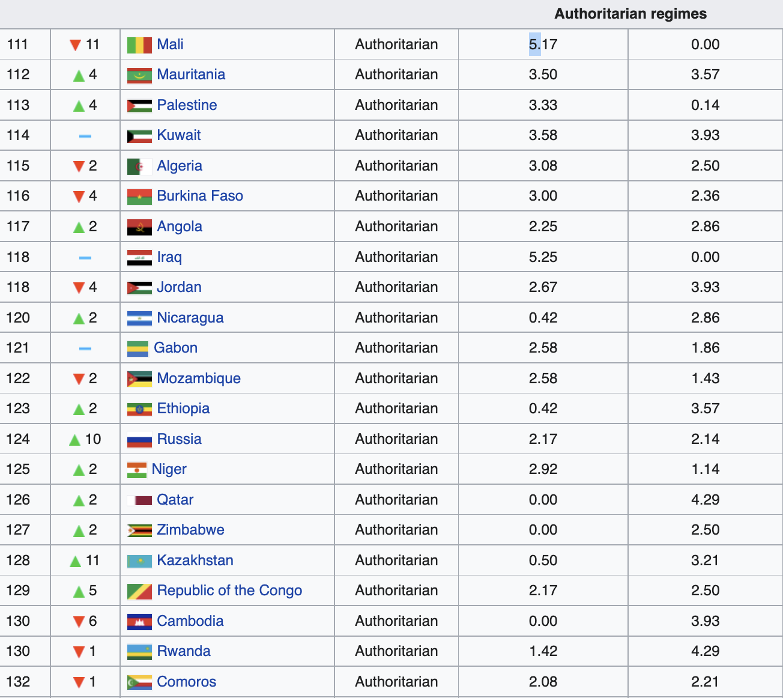
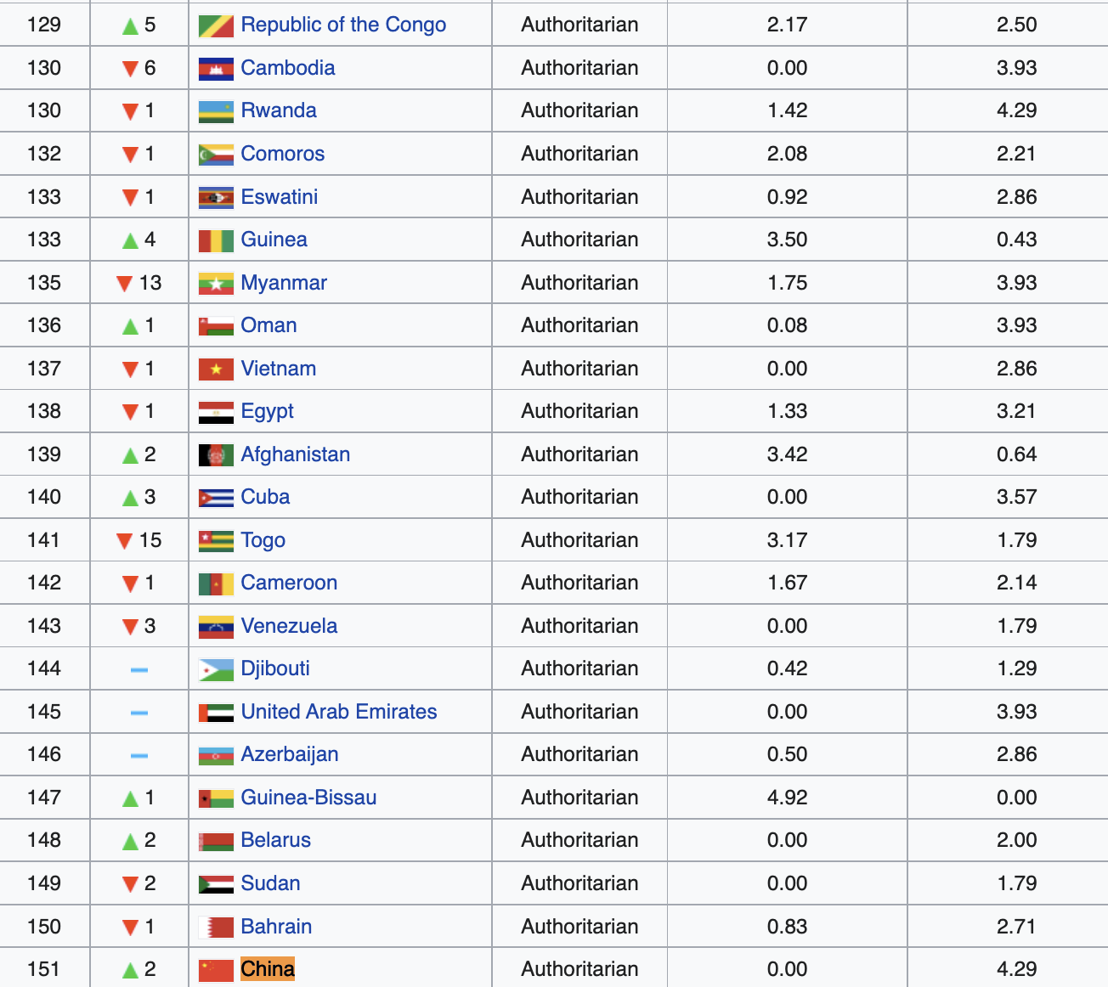
Wikipedia cites Economist Intelligence Unit, 2020, Democracy Index, https://en.wikipedia.org/wiki/Democracy_Index //SR
Full democracies are nations where civil liberties and fundamental political freedoms are not only respected but also reinforced by a political culture conducive to the thriving of democratic principles. These nations have a valid system of governmental checks and balances, an independent judiciary whose decisions are enforced, governments that function adequately, and diverse and independent media. These nations have only limited problems in democratic functioning.[8] Flawed democracies are nations where elections are fair and free and basic civil liberties are honoured but may have issues (e.g. media freedom infringement and minor suppression of political opposition and critics). These nations have significant faults in other democratic aspects, including underdeveloped political culture, low levels of participation in politics, and issues in the functioning of governance.[8] Hybrid regimes are nations with regular electoral frauds, preventing them from being fair and free democracies. These nations commonly have governments that apply pressure on political opposition, non-independent judiciaries, widespread corruption, harassment and pressure placed on the media, anaemic rule of law, and more pronounced faults than flawed democracies in the realms of underdeveloped political culture, low levels of participation in politics, and issues in the functioning of governance.[8] Authoritarian regimes are nations where political pluralism is nonexistent or severely limited. These nations are often absolute monarchies or dictatorships, may have some conventional institutions of democracy but with meagre significance, infringements and abuses of civil liberties are commonplace, elections (if they take place) are not fair and free, the media is often state-owned or controlled by groups associated with the ruling regime, the judiciary is not independent, and censorship and suppression of governmental criticism are commonplace.[8]

Vote neg for limits and ground - they can literally pick any government not grounded in the resolution making it impossible for us to predict and arbitrarily prepare specific political scenarios that we can never possibly expect. Especially true for authoritarian governments who have a lot worse conditions than democracies which means uniqueness will ALWAYS flip aff and their affs are objectively more likely to be true and unturnable. Our interp solves - just pick a full or flawed democracy which is still 75 different affs. C/a the ! to limits and precision

4
The neg burden is to prove that the aff won’t logically happen in the status quo, and the aff burden is to prove that it will. Prefer:
1] Text –
A] Ought is “used to express logical consequence” as defined by Merriam-Webster
(http://www.merriam-webster.com/dictionary/ought) //Massa
B] Oxford Dictionary defines ought as “used to indicate something that is probable.”
https://en.oxforddictionaries.com/definition/ought //Massa
2] Resolvability - you can only only disprove a fw from the perspective of another fw so it begs the question of a higher framework to evaluate phil debate and so on. That inevitably forces judge intervention as the judge has to use their own framework, which outweighs because all arguments presume the judge to resolve them.
3] Neg definition choice – the aff should have defined ought in the 1ac because it was in the rez so it’s predictable contestation, by not doing so they have forfeited their right to read a new definition – kills 1NC strategy since I premised my engagement on a lack of your definition.

Now negate:
1] Inherency – either a) the aff is non-inherent and you vote neg on presumption or b) it is and it isn’t going to happen since there are structural barriers that preclude. Also you don’t get to say in the 1ar that the aff is non inherent because you took a stance in the aff that it was which is an academic integrity issue.
2] Motion is impossible – to go anywhere, you have to go half way, then half of that half ad infinitum traversing infinite spaces in finite time - that means its impossible to take an action to do the aff
3] Either it’s the case we can predict the outcome of a situation, or we cannot. We cannot, insofar as no situation is ever replicated exactly, and even if it can, there’s no guarantee the outcome will be the same. If we can predict situations, that means everyone can, which means we will always predict each other, making a paradox of action insofar as we always attempt to predict the outcomes of each other’s actions, and will cancel out the obligations. If we can’t predict it, its not probable

Advantage 1
[insert democracy bad]

Advantage 2
[insert warming good]

