SEPTOCT 2017 – T File

Definitions

Resolved

Resolved reflects policy passage before a legislative body. Parcher 01
(Jeff, Fmr. Debate Coach at Georgetown University, February, http://www.ndtceda.com/archives/200102/0790.html)

(1) Pardon me if I turn to a source besides Bill. American Heritage Dictionary: Resolve: 1. To make a firm decision about. 2. To decide or express by formal vote. 3. To separate something into constituent parts See Syns at *analyze* (emphasis in orginal) 4. Find a solution to. See Syns at *Solve* (emphasis in original) 5. To dispel: resolve a doubt. - n 1. Frimness of purpose; resolution. 2. A determination or decision. (2) The very nature of the word "resolution" makes it a question. American Heritage: A course of action determined or decided on. A formal statemnt of a deciion, as by a legislature. (3) The resolution is obviously a question. Any other conclusion is utterly inconcievable. Why? Context. The debate community empowers a topic committee to write a topic for ALTERNATE side debating. The committee is not a random group of people coming together to "reserve" themselves about some issue. There is context - they are empowered by a community to do something. In their deliberations, the topic community attempts to craft a resolution which can be ANSWERED in either direction. They focus on issues like ground and fairness because they know the resolution will serve as the basis for debate which will be resolved by determining the policy desireablility of that resolution. That's not only what they do, but it's what we REQUIRE them to do. We don't just send the topic committee somewhere to adopt their own group resolution. It's not the end point of a resolution adopted by a body - it's the prelimanary wording of a resolution sent to others to be answered or decided upon. (4) Further context: the word resolved is used to emphasis the fact that it's policy debate. Resolved comes from the adoption of resolutions by legislative bodies. A resolution is either adopted or it is not. It's a question before a legislative body. Should this statement be adopted or not. (5) The very terms 'affirmative' and 'negative' support my view. One affirms a resolution. Affirmative and negative are the equivalents of 'yes' or 'no' - which, of course, are answers to a question.

“Resolved” before a colon reflects a policy enactment. AOS
Army Officer School (5-12-04, “# 12, Punctuation – The Colon and Semicolon”, http://usawocc.army.mil/IMI/wg12.htm)

The colon introduces the following: a. A list, but only after "as follows," "the following," or a noun for which the list is an appositive: Each scout will carry the following: (colon) meals for three days, a survival knife, and his sleeping bag. The company had four new officers: (colon) Bill Smith, FranTucker, Peter Fillmore, and Oliver Lewis. b. A long quotation (one or more paragraphs): In The Killer Angels Michael Shaara wrote: (colon) You may find it a different story from the one you learned in school. There have been many versions of that battle [Gettysburg] and that war [the Civil War]. (The quote continues for two more paragraphs.) c. A formal quotation or question: The President declared: (colon) "The only thing we have to fear is fear itself." The question is: (colon) what can we do about it? d. A second independent clause which explains the first: Potter's motive is clear: (colon) he wants the assignment. e. After the introduction of a business letter: Dear Sirs: (colon) Dear Madam: (colon) f. The details following an announcement For sale: (colon) large lakeside cabin with dock g. A formal resolution, after the word "resolved:" Resolved: (colon) That this council petition the mayor.

In

Merriam-Webster defines in as
[Merriam-Webster Dictionary, “in,” https://www.merriam-webster.com/dictionary/in]
used as a function word to indicate inclusion, location, or position within limits

United States

United States requires either state or federal government action
Stone 45 – SCOTUS Chief Justice
[Harlan, HOOVEN & ALLISON CO. v. EVATT, 324 U.S. 652 (1945) 324 U.S. 652, decided April 9, 1945, caselaw.lp.findlaw.com/scripts/getcase.pl?navby=case&court=us&vol=324&page=652, accessed 7-24-14]

The term 'United States' may be used in any one of several senses. It may be merely the name of a sovereign occupying the position analogous to that of other sovereigns in the family of nations. It may designate the territory over which the sovereignty of the United States ex- [324 U.S. 652, 672] tends, or it may be the collective name of the states which are united by and under the Constitution.

National Service

Dictionary.com: national service is
“National service.” Cambridge Dictionary. http://dictionary.cambridge.org/us/dictionary/english/national-service //nhs-VA
the system in some countries by which young people, especially men, are ordered by law to spend a period of time in the armed forces:

That means conscription – Merriam Webster defines it as
“Conscription.” Merriam-Webster, Merriam-Webster, www.merriam-webster.com/dictionary/conscription. //nhs-VA

compulsory enrollment of persons especially for military service: draft

Most consistent with the lit. Cooper 77
Cooper, Richard V. L. “A National Service Draft?” May 1977. https://www.rand.org/content/dam/rand/pubs/papers/2008/P5880.pdf //nhs-VA

The choice of a military manpower procurement policy has traditionally been among the more important decisions that a nation must make. Besides its effects on defense capabilities and costs, manpower procurement policy has much broader economic and social implications. This is especially so for compulsory national service, a policy option that has recently begun to receive considerable public attention. It is within the context of these defense, economic, and social considerations that the purpose of this paper is to sketch out a general approach for evaluating the efficacy of a national service draft, including some of the possible consequences that such a policy would entail. Of particular importance to this evaluation is a careful consideration of the progress and prospects for the All-Volunteer Force. That is, compulsory national service should not be viewed in isolation from military manpower procurement since the military is one of the largest claimants of the nation’s youth. Consideration of compulsory national service in the context of the AVF is further motivated by the fact that much of the support for a national service draft seems to derive at least in part from concerns about the future of the volunteer force. Thus, to the extent that these concerns are misplaced, the rationale for a national service draft is correspondingly lessened.

Ought to be

“Ought to be” in the resolution is evaluative, not deliberative—means the aff must prove that a world in which ___ is better than the alternative.
Finlay and Sendegar 12, Finlay, S. [Associate Professor of Philosophy at USC] & Snedegar, J. [PhD candidate in philosophy at the University of Southern California], (2012). One Ought Too Many. Philosophy and Phenomenological Research.

The nonagential sentences (1) and (2) say that certain states of affairs ought to be the case (the “ought-to-be”). Here ‘ought’ is commonly glossed as meaning it is best that... , so we can call these readings evaluative.4,5 From some state of affairs being best nothing directly follows about how any agent has most reason to act, and so these sentences seem to have at most an indirect bearing on agents’ deliberations. Sentence (2) entails neither that somebody has most reason to rig the lottery so Larry wins, for example, nor even that Larry has most reason to buy a lottery ticket (the odds of his winning would after all be extremely long). By contrast, the agential sentences (3) and (4) on a natural reading do seem to entail claims about the agents’ reasons to act, and so to bear directly on their deliberations (the “ought-to-do”). They do not, however, entail that any particular state of affairs would be best. We can call these readings deliberative. Mark Schroeder identifies five hallmarks that distinguish deliberative readings from evaluative readings. Unlike the evaluative ‘ought’, the deliberative ‘ought’ (i) matters directly for advice; (ii) functions to close deliberation; (iii) is characteristically tied to assessments of agents’ accountability; (iv) implies ‘can’;6 and (v) is closely related to obligation.7 We agree that these differences between readings exist, but reject the claim that the Uniformity Thesis cannot accommodate and explain them.

Compulsory

Oxford dictionary defines compulsory as
[Oxford Dictionaries, "compulsory," https://en.oxforddictionaries.com/definition/compulsory]
Required by law or a rule; obligatory

1NC – National service

Interp

Dictionary.com: national service is
“National service.” Cambridge Dictionary. http://dictionary.cambridge.org/us/dictionary/english/national-service //nhs-VA
the system in some countries by which young people, especially men, are ordered by law to spend a period of time in the armed forces:

That means conscription – Merriam Webster
“Conscription.” Merriam-Webster, Merriam-Webster, www.merriam-webster.com/dictionary/conscription. //nhs-VA

compulsory enrollment of persons especially for military service: draft

Most consistent with the lit. Cooper 77
Cooper, Richard V. L. “A National Service Draft?” May 1977. https://www.rand.org/content/dam/rand/pubs/papers/2008/P5880.pdf //nhs-VA

The choice of a military manpower procurement policy has traditionally been among the more important decisions that a nation must make. Besides its effects on defense capabilities and costs, manpower procurement policy has much broader economic and social implications. This is especially so for compulsory national service, a policy option that has recently begun to receive considerable public attention. It is within the context of these defense, economic, and social considerations that the purpose of this paper is to sketch out a general approach for evaluating the efficacy of a national service draft, including some of the possible consequences that such a policy would entail. Of particular importance to this evaluation is a careful consideration of the progress and prospects for the All-Volunteer Force. That is, compulsory national service should not be viewed in isolation from military manpower procurement since the military is one of the largest claimants of the nation’s youth. Consideration of compulsory national service in the context of the AVF is further motivated by the fact that much of the support for a national service draft seems to derive at least in part from concerns about the future of the volunteer force. Thus, to the extent that these concerns are misplaced, the rationale for a national service draft is correspondingly lessened.

Shell

Ground
They try to shift out of every core neg argument that links to the military or even the CNCS like econ, war powers, crime, incentives CP, objectors CP, FEMA CP. Topic lit never addresses national service as being two separate words rather as a term of art. Forces the neg into generics like Wilderson and cap every time which just leads to lower quality debates.

Predictable Limits
Your interp explodes affs – climate “service”, religious service, increasing tech and utilities innovation, ANY public department or organization run by the government are all possible. All minute without any actual DAs and all have VERY diverse advantage ground, so its impossible to cut advantage CP ground. Skews neg prep burden and guarantees that we’ll will always get destroyed by 1ar frontlines. AND even definitions of service on its own includes “voluntary service” and “the armed forces.”
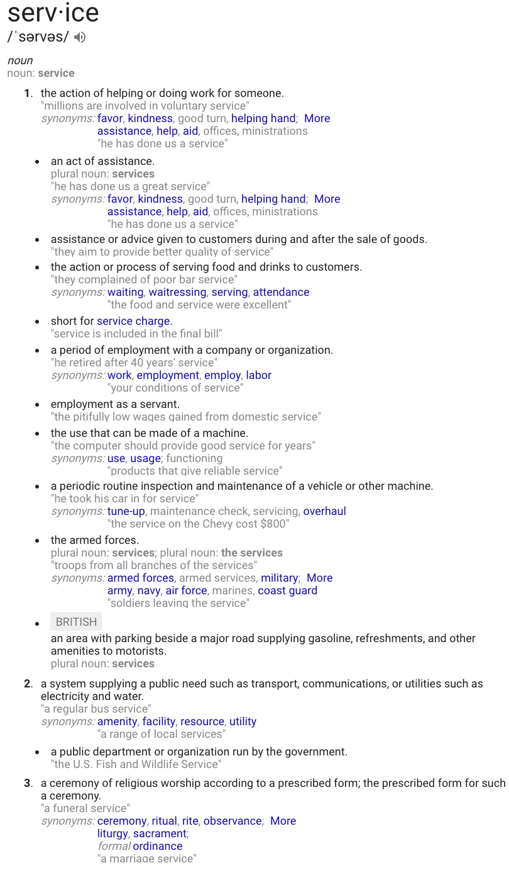

1NC – Must be military

Interp

Dictionary.com: national service is
“National Service.” Dictionary.com, Dictionary.com, www.dictionary.com/browse/national-service. //nhs-VA
compulsory military service

That means conscription – Merriam Webster
“Conscription.” Merriam-Webster, Merriam-Webster, www.merriam-webster.com/dictionary/conscription. //nhs-VA

compulsory enrollment of persons especially for military service: draft

Most consistent with the lit. Cooper 77
Cooper, Richard V. L. “A National Service Draft?” May 1977. https://www.rand.org/content/dam/rand/pubs/papers/2008/P5880.pdf //nhs-VA

The choice of a military manpower procurement policy has traditionally been among the more important decisions that a nation must make. Besides its effects on defense capabilities and costs, manpower procurement policy has much broader economic and social implications. This is especially so for compulsory national service, a policy option that has recently begun to receive considerable public attention. It is within the context of these defense, economic, and social considerations that the purpose of this paper is to sketch out a general approach for evaluating the efficacy of a national service draft, including some of the possible consequences that such a policy would entail. Of particular importance to this evaluation is a careful consideration of the progress and prospects for the All-Volunteer Force. That is, compulsory national service should not be viewed in isolation from military manpower procurement since the military is one of the largest claimants of the nation’s youth. Consideration of compulsory national service in the context of the AVF is further motivated by the fact that much of the support for a national service draft seems to derive at least in part from concerns about the future of the volunteer force. Thus, to the extent that these concerns are misplaced, the rationale for a national service draft is correspondingly lessened.
This interp is not mutually exclusive with spec – you can gain spec benefits by just speccing within the military.

Shell

Ground
They try to shift out of disads like NoKo, crime and econ, incentives CP which are a core part of the neg strategy. DAs are key to topic education. Topic lit never addresses national service as ONLY being in the peace corps. Forces the neg into generics like Wilderson and cap every time which just leads to lower quality debates.

Predictable Limits
Your interp explodes affs – citizen corps, peace corps, AmeriCorps, learn and serve, senior corps, volunteer.gov, fire corps. All minute without any actual DAs and all have VERY diverse advantage ground, so its impossible to cut advantage CP ground PLUS these affs are functionally truisms. Skews neg prep burden and guarantees that we’ll will always get destroyed by 1ar frontlines.

1NC – Must defend all citizens

Interp

National service requires all men and women to serve – either they bite the T interp or they don’t solve
Brennan and Upshaw 12 – Matthew and Kyle, Naval Postgraduate School (“AMERICAN SERVICE: NEW NATIONAL SERVICE FOR THE UNITED STATES” http://www.dtic.mil/dtic/tr/fulltext/u2/a573814.pdf) LADI
UNIVERSALITY IS A MUST . . . YES, IT MUST BE COMPULSORY • All men and women must participate in a program to achieve the desired benefits of national service. As evidenced by case studies in Israel, Singapore, and India, without full participation the outcomes of the program will never fully meet the original objectives. • Service must be accomplished by men and women some time between the ages of sixteen and twenty-five. For example, high school dropouts could serve as early as sixteen years of age. Others could serve upon completing high school, and could use their national service experience to explore different possibilities for where they may seek work afterwards. For others, by expanding the upward boundary for service to twenty-five, individuals could complete college prior to completing their service

Oxford dictionary defines compulsory as
[Oxford Dictionaries, "compulsory," https://en.oxforddictionaries.com/definition/compulsory]
Required by law or a rule; obligatory

Merriam-Webster defines in as
[Merriam-Webster Dictionary, “in,” https://www.merriam-webster.com/dictionary/in]
used as a function word to indicate inclusion, location, or position within limits

Compulsory national service is universal. Cooper 77
Cooper, Richard V. L. “A National Service Draft?” May 1977. https://www.rand.org/content/dam/rand/pubs/papers/2008/P5880.pdf //nhs-VA

Under a compulsory national service policy, all young men (and on occasion, all young women) are viewed as having an obligation to serve their country. Such service is usually designed to benefit the national purpose and can include, for instance, helping the disadvantaged members of society (e.g., working in hospitals or programs such as VISTA), forestry and park services, and, of course, military service.

Shell

Ground
They try to shift out of disads like crime and econ, incentives CP which are a core part of the neg strategy. DAs are key to topic education. Topic lit never addresses national service as ONLY drafting a specific group of people. Forces the neg into generics like Wilderson and cap every time which just leads to lower quality debates.

Predictable Limits
Your interp explodes affs – HW’s 1% aff, STPP, disabled citizens, etc. All minute without any actual DAs and all have VERY diverse advantage ground, so its impossible to cut CPs. Skews neg prep burden and guarantees that we’ll will always get destroyed by 1ar frontlines.

