T – Democracy

**1NC – Dem Index**

Shell - Short

Interp – topical democracies are those listed in the Economist Intelligent Unit’s 2018 Democracy Index as full democracies– ___ isn’t T.

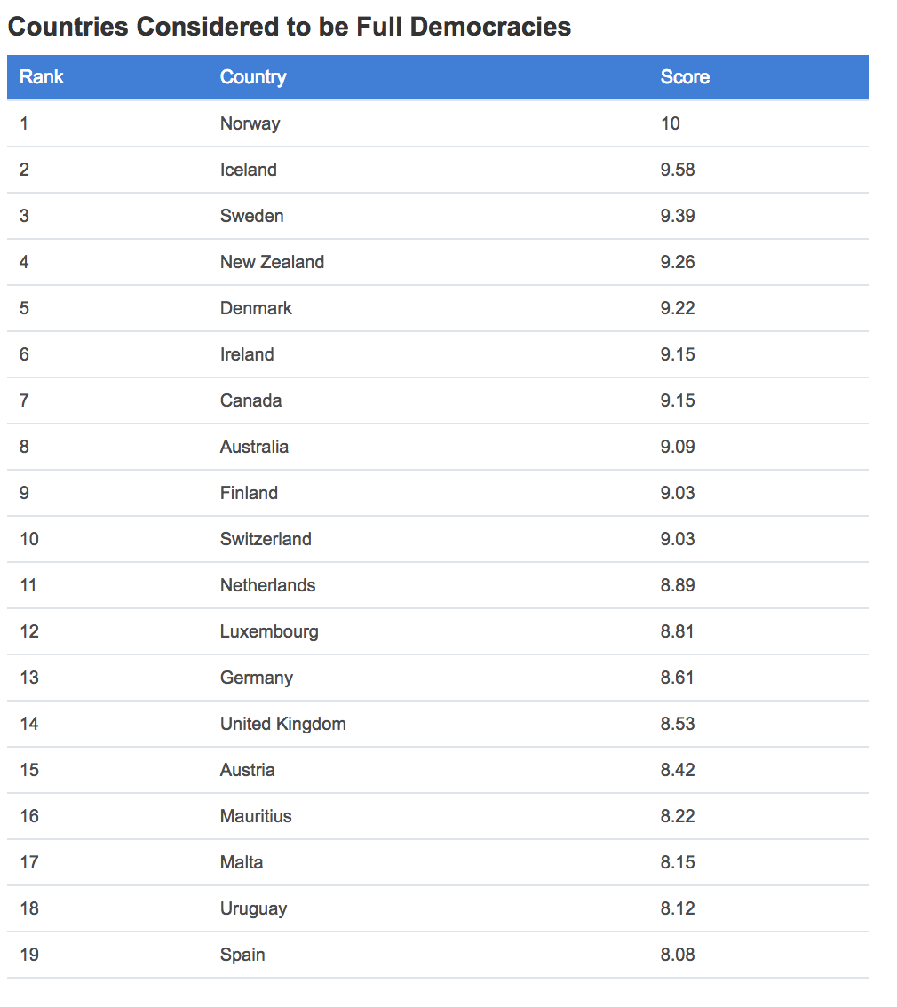
https://www.worldatlas.com/articles/countries-considered-to-be-full-democracies.html OHS-AT

Dem index o/ws – accounts for modern global politics that define the ground of the topic.

1] Limits – only full democracies draw a clear line of topical affs – anything else arbitrarily explodes limits
EIU ’17 [British business within the Economist Group providing forecasting and advisory services through research and analysis, such as monthly country reports, five-year country economic forecasts, country risk service reports, and industry reports. The EIU provides country, industry, and management analysis worldwide and incorporates the former Business International Corporation, a UK company acquired by its parent company in 1986. The EIU has several offices across the globe including two offices in China and one in Hong Kong] “Democracy Index 2017” 2017. https://pages.eiu.com/rs/753-RIQ-438/images/Democracy_Index_2017.pdf IB
Democracy Index 2017, by regime type
No. of countries % of countries % of world population
Full democracies 19 11.4 4.5
Flawed democracies 57 34.1 44.8
Hybrid regimes 39 23.4 16.7
Authoritarian regimes 52 31.1 34.0
Note. “World” population refers to the total population of the 167 countries covered by the Index. Since this excludes only micro states, this is nearly equal to the entire estimated world population.

Limits key to fairness and education by ensuring a manageable prep burden to engage the aff.

2] Topic lit - full democracies are most germane to the value question of the topic.
Salome Chelangat 18 “Countries Considered to Be Full Democracies” World Atlas. May 16, 2018. https://www.worldatlas.com/articles/countries-considered-to-be-full-democracies.html IB
Full democracy refers to the system whereby all the democratic principles are upheld. Nations practicing a full democracy have political cultures such that freedom and civil liberties are upheld. All of the arms of government such as the executive and judiciary are independent. Other aspects such as the opposition and the media are respected since they ensure checks and balances.

**Frontlines**

AT: Predictability

1] It’s predictable – a) first result when you search list of democratic countries. b) well-known, thorough study that’s cited commonly – measures 167 countries.

2] Limits controls the internal link to predictability – ensures a modest subset of affs that can be reasonably prepped.

**1NC – No Dumb Countries**

Shell

Interp – affs must defend a democracy as a
https://www.dictionary.com/browse/democracy OHS-AT

government by the people; a form of government in which the supreme power is vested in the people and exercised directly by them or by their elected agents under a free electoral system.

[insert violation]

Vote neg –

1] Limits – including any country that has a resemblance of an electoral process explodes the number of affs – there are 193 countries with elections alongside infinite permutations since only Brunei and Eritrea don’t hold any. Limits key to fairness and education by ensuring a manageable prep burden to engage the aff.
https://foreignpolicy.com/2013/11/06/the-country-thats-never-had-an-election/
https://en.wikipedia.org/wiki/Politics_of_Brunei

2] Ground – allows uncontestable affs since nobody except Russia hacks write why Putin should stay secret. Also especially true on this topic – stock neg positions like cap don’t link to countries with radically different political systems. Err neg – we know the topic was a bad way of talking about Trump’s tax returns

Violation - China

China doesn’t meet
Shrinag 10/20 Shrinag, 10-20-2018, "Why is China not a Democratic Country? Here are the 10 Reasons for China being a Communist Country," MetroSaga, https://metrosaga.com/why-is-china-not-a-democratic-country/ OHS-AT
China held elections every five years to elect the Country’s parliament but National People’s Congress (NPC) holds the authority of appointing the President of the Country. Only the members of the CPC or other small parties allied to it are allowed to contest Elections (E.x: 2002-03 Elections). A government in China is always formed by the Communist party nullifying the crux of Democracy.
Since there is no free and fair chance for people to choose their representative, China will not come under the shades of Democracy.

Violation – Russia

Russia OBVIOUSLY doesn’t meet – no free electoral systems
Grodsky 5/22 Brian Grodsky, 5-22-2018, "Russia, Putin lead the way in exploiting democracy's lost promise," Conversation, https://theconversation.com/russia-putin-lead-the-way-in-exploiting-democracys-lost-promise-94798 OHS-AT
Putin dismantled democracy
Since taking power, Putin has cast himself as Yeltsin’s antithesis and Russia’s savior. He has consolidated power with a strategy based on hope, destruction and suspicion of perceived enemies, whether terrorists or democrats.
In his first two terms, from 2000 to 2008, Putin inspired hope, with the first pillar of his rule, by reversing Russia’s decade-long slide into economic turmoil. Thanks to increasing energy prices, the economy grew by 83 percent and the purchasing power of Russia’s citizens more than doubled to US$21,600. Rising oil and gas revenues filled state coffers and allowed Putin to revive governmental spending on everything from social welfare to military modernization.
Putin also stuck up for the everyday Russian, chasing and even jailing the so-called oligarchs, or at least those who refused to stay out of politics. Regional fiefdoms went back to bowing to Moscow.
To maintain this image of security and prosperity, Putin has relied on a second pillar: destruction.
Yeltsin’s Russia was never a hallmark of democracy. But over the past 18 years, Putin has worked to dismantle whatever inconvenient democratic institutions managed to take root.
Free media outlets were shuttered. Civil society organizations were strangled. Electoral institutions were carefully manipulated to ensure Putin and the United Russia party backing him could not be beat.
According to Freedom House, a nonprofit organization that rates countries based on political rights and civil liberties, Russia now ranks among the least democratic fifth of all countries in the world.
It’s nearly impossible to contest Putin today. Media freedom has been severely curtailed with state media coverage practically scripted by the Kremlin. Those who stand up to Putin risk arrest and imprisonment. Many of Putin’s most vociferous foes have died under mysterious circumstances.
Putin’s destruction of democratic institutions has guaranteed his time in power will exceed that of Russia’s brutal dictator, Joseph Stalin, who consolidated power in the 1920s and ruled until his death in 1953.

