TOC – Military Aid

1NC

Shell

Interpretation: Military aid is bilateral military loans and grants as defined by the USAID Greenbook
Sullivan et al 11 - Patricia L. Sullivan (UGA), Brock F. Tessman (UGA), Xiaojun Li (Stanford), “US Military Aid and Recipient State Cooperation”, Foreign Policy Analysis (2011) 7, 275–294 WJ
We define military aid as ‘‘total bilateral military assistance loans and grants’’ as reported by USAID through its Overseas Loans and Grants (Greenbook). The ‘‘Greenbook’’ measure of military assistance includes aid for several programs, including International Military Education and Training, Military Assistance Program Grants, Foreign Military Credit Financing, and Transfers of Excess Defense Articles.4 The measure excludes military assistance that is given for economic development purposes (which is captured in a separate measure of economic aid) and assistance given for counternarcotics and counterproliferation efforts, as well commercial military sales (USAID).5 We use the natural log of total US military aid delivered to a country in constant 2002 US dollars in our models. We also create a variable (milaiddep) that measures the relative dependence of the recipient country on US military aid. This variable is generated by dividing the amount of military aid by the GDP of the recipient country.6
BEGIN FOOTNOTE 4 Cited Above
For countries that receive the largest amount of US military assistance, the vast majority of aid comes as part of the Foreign Military Financing Program (FMFP). According to the US State Department, the FMFP is designed to "provide grants for the acquisition of US defense equipment, services, and training." In 2006, FMFP funds accounted for over 90 percent of total military aid to Egypt, Israel, Pakistan, Jordan, Colombia, the Philippines, and Poland.

Here’s examples of what military aid includes. Rolandsen 18
Øystein H. Rolandsen, Peace Pesearch Institute Oslo (Prio), Jan-Dec 2018, "The Impact of Military Aid on Conflict Resolution, Prevention and Stability in the Sahel and Horn of Africa," No Publication, https://www.prio.org/Projects/Project/?x=1795, Co-director PRIO Centre for Culture and Violent Conflict, Editorial Board member of the Centre for Peace and Development (CPDS) Journal, University of Juba, South Sudan and received Ph. D. in History from University of Oslo in 2010

​The provision of military aid is the most common policy tool used by Western states attempting to influence conflict and security in recipient countries. The aid includes donation of training, weapons, other military equipment, non-military stores (e.g. fuel), and other services (e.g. intelligence), to the armed forces as well as coast guards and border guards. Compared to other forms of intervention, military aid is considered economical, sustainable and easy to adapt to the local context. In addition, these programs are usually popular with recipient governments.

Violation: CX + every card in the aff references arms sales, which isn’t aid

[x country] did not receive military aid – here’s screenshots from the Security Assistance Monitor, which gets its data from USAID

Prefer –

Extra-T – allowing them to include arms sales means they resolve core fill-in debates since the US no longer provides foreign military sales in addition to foreign military financing. Hold them to what their interp justifies – they can add tangentially-related planks to the plan and garner solvency to outweigh any disads that do link

Limits – 2 internal links that substantially increase negative prep burden and make it impossible to negate:

Aiding the military: arms sales are a commercial transaction; their interp justifies ending economic treaties with regimes since it could aid a regime’s military, but “military aid” as a term of art does not include it. Other examples include:

More regimes: the following are the countries that only receive arms sales, and not aid: Saudi, UAE, Ukraine, Cameroon. Core disads like terror, IMET, and PKO don’t apply.

Vote neg –

Debate’s a competitive game – fairness restricts how much education we take away

Drop the debater to deter abuse and protect time lost

Use competing interps – reasonability on T lets aff debaters race to the margins since it begs the question of what’s reasonable, which invites judge intervention; any bright line is self-serving and arbitrary

No RVIs – reasonability checks against frivolous theory, so deterring debaters from checking abuse outweighs

SAM

Arms Sales Dashboard
“Arms Sales Dashboard” Security Assistance Monitor. http://securityassistance.org/content/arms-sales-dashboard

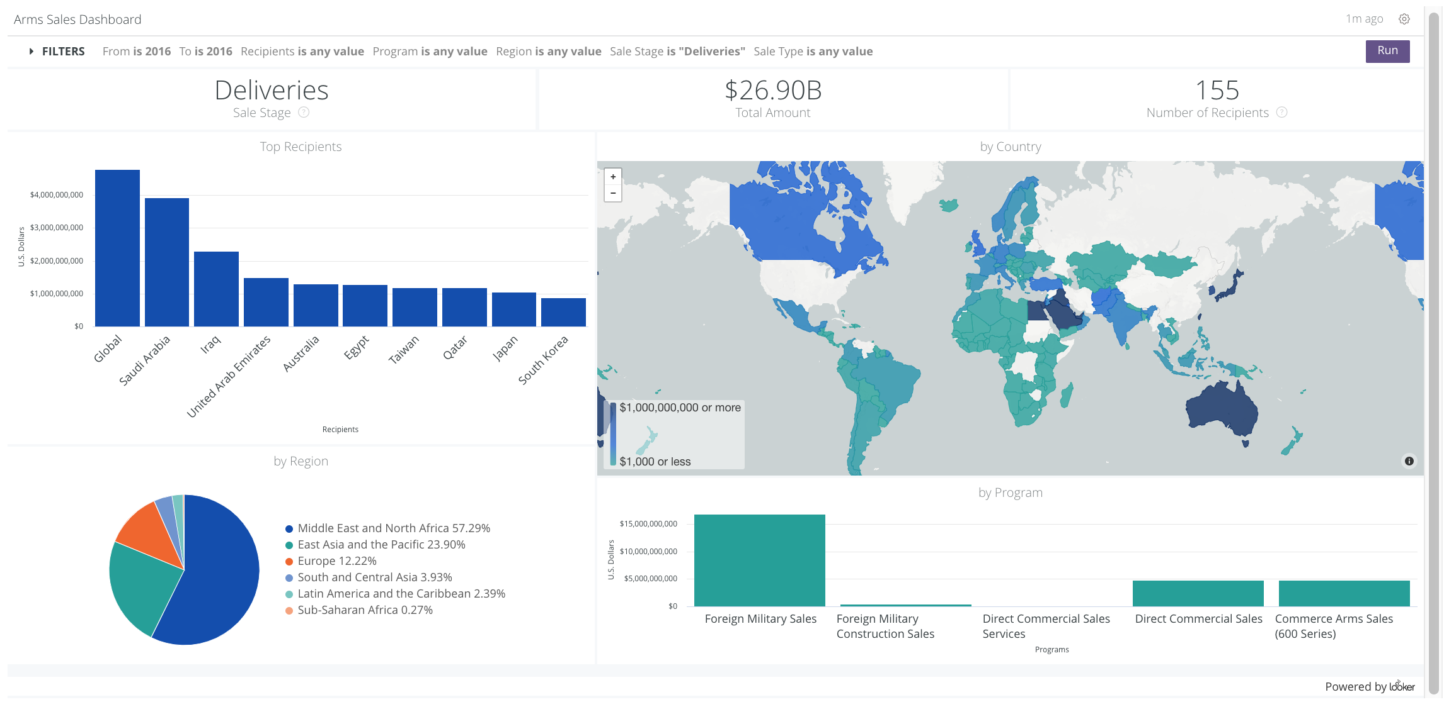

Security Aid Dashboard
“Security Aid Dashboard” Security Assistance Monitor. http://securityassistance.org/content/security-aid-dashboard

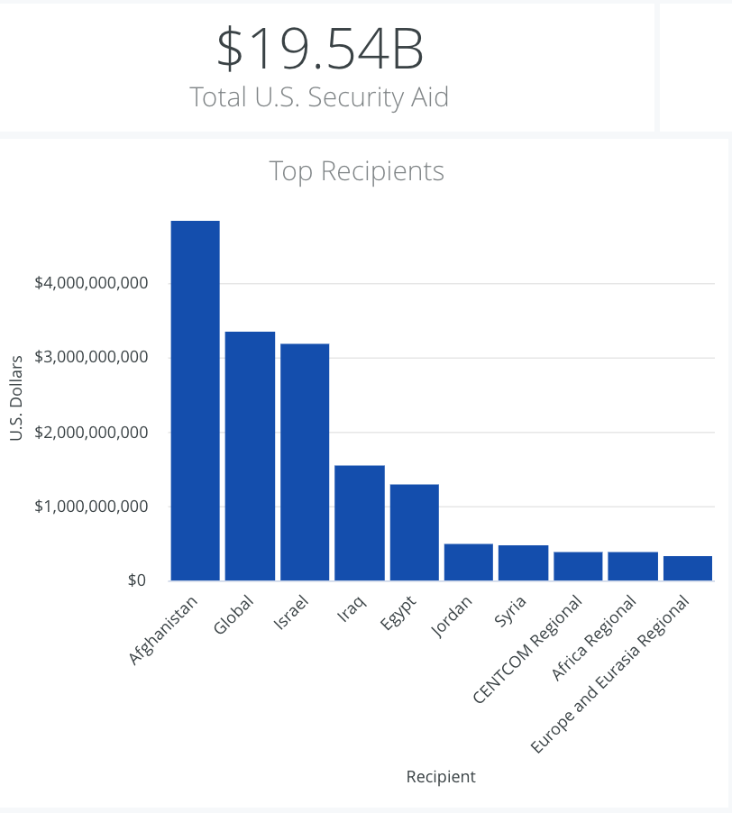

Countries

Saudi
Security Assistance Monitor 19 (http://securityassistance.org/data/program/military/Saudi%20Arabia/2012/2019/all/Global//
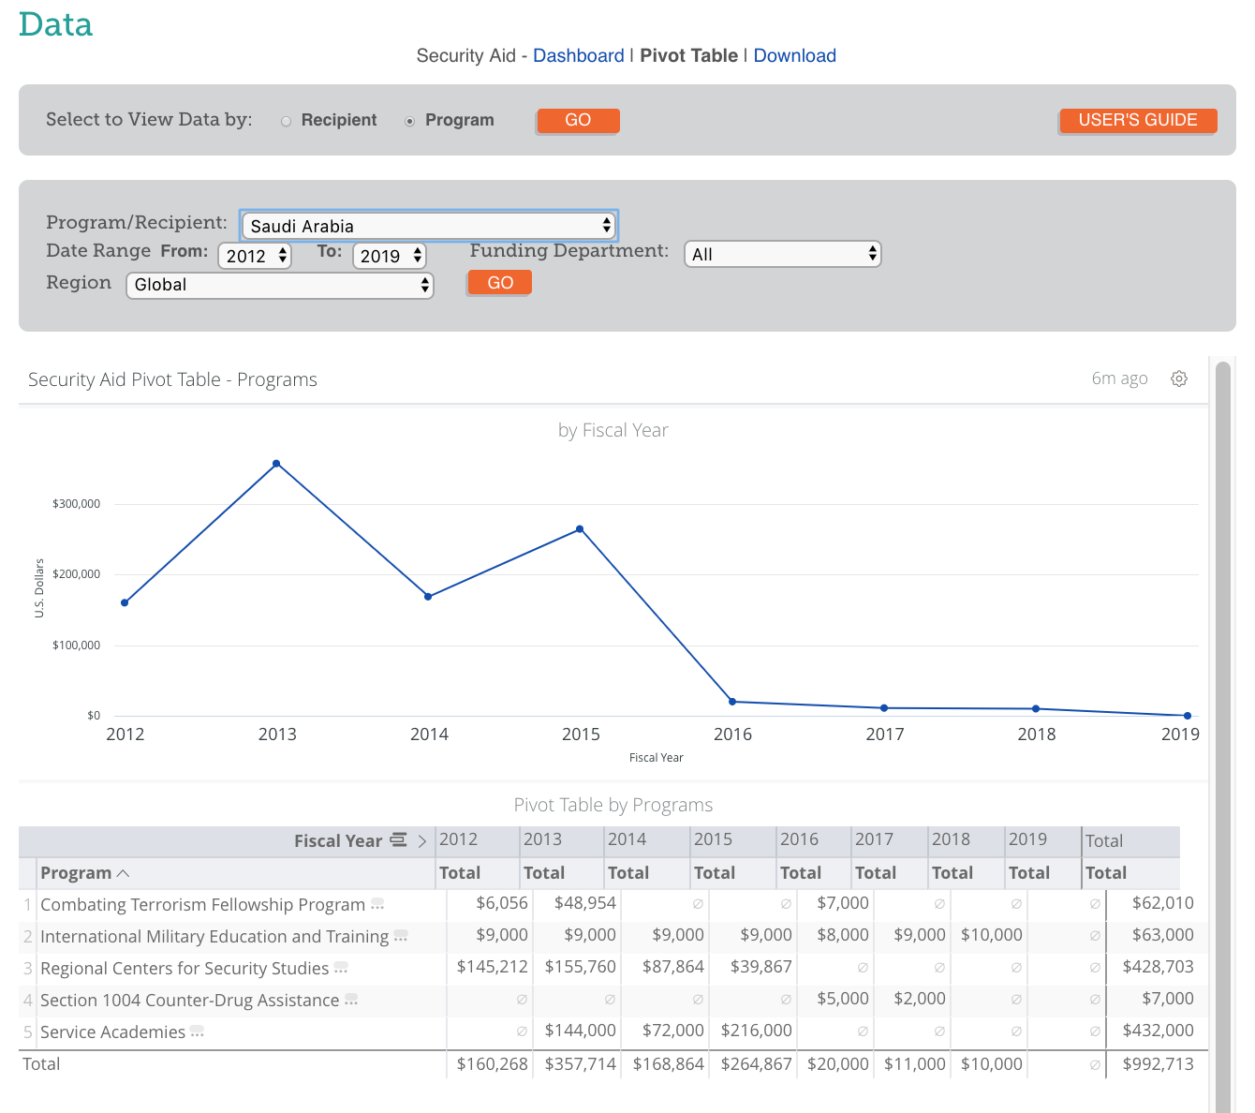

UAE
Security Assistance Monitor 19
(http://securityassistance.org/data/program/military/United%20Arab%20Emirates/2012/2019/all/Global//
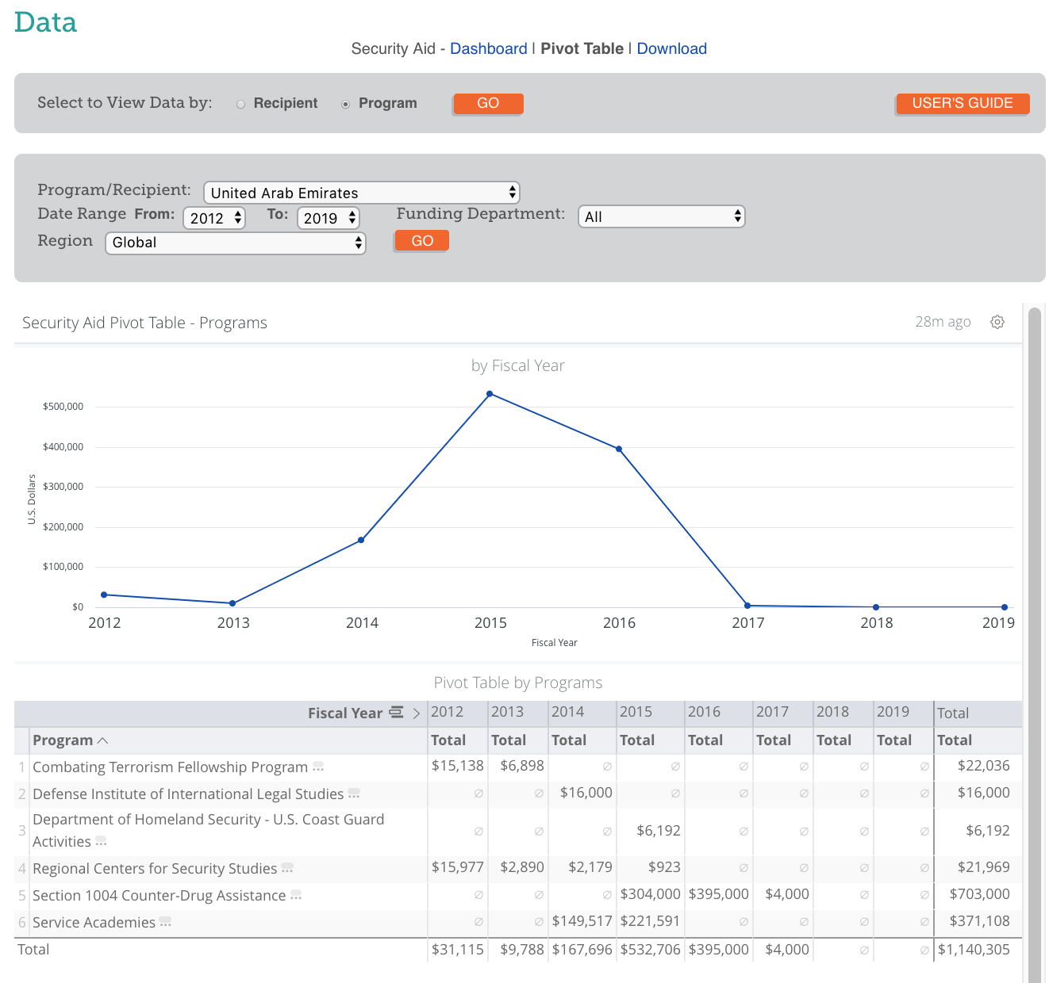

Saudi = FMS

Saudi Arabia is not part of FMF.c
Robertson ’16 [Lori Robertson, 4-12-2016, "U.S. Foreign Military Support," FactCheck.org, https://www.factcheck.org/2016/04/u-s-foreign-military-support/] KD
Military Aid Let’s start with the easy part: what the United States spends on foreign military aid overall, and to these countries in particular. Total foreign aid, of all kinds, was an estimated $35.3 billion in 2014, and $5.9 billion of that was military financing with another $105.6 million for international military education and training, according to State Department figures on foreign assistance (see Table 3b). Most of the military financing (75 percent) went to Israel and Egypt. That’s followed by Iraq, Jordan and Pakistan. The countries Trump mentioned — Saudi Arabia, Japan, Germany and South Korea — didn’t receive any foreign military financing, though Saudi Arabia received $10,000 for military education and training

Arms sales are FMS – our ev talks about the Saudi deal specifically.
D.O.S 18 (“U.S. Security Cooperation With Saudi Arabia”, Share Fact Sheet BUREAU OF POLITICAL-MILITARY AFFAIRS October 16, 2018, https://www.state.gov/t/pm/rls/fs/2018/279540.htm?fbclid=IwAR2PuGBGoIy-gst5mDt0H8gdq-peWQF4FtuRKUxGC4PMlpikgRocbUGBimI) LHSLA JC
Saudi Arabia is the United States’ largest foreign military sales (FMS) customer, with over $114 billion in active cases. With the signing of the May 2017 $110 billion agreement to pursue Saudi Armed Forces modernization by President Trump and King Salman, we expect a significant increase in FMS and DCS cases. To date this initiative resulted in over $14.5 billion in implemented FMS cases. In January 2017, the United States approved a possible FMS case to Saudi Arabia for a Persistent Threat Detection System (PTDS), also known as a 74K Aerostat System, for an estimated cost of $525 million. In May 2017, the United States approved an FMS sale to Saudi Arabia for continuation of a naval blanket order training program for an estimated cost of $250 million. In June 2017, the United States approved the continuation of a blanket order training program that includes flight training, technical training, professional military education, specialized training, mobile training teams, and English language training, valued at $750 million. In June 2017, the United States approved a possible sale of 26 AN/TPQ-53(V) Radar Systems and related training and equipment for an estimated cost of $930 million. As part of a Saudi Arabia eastern fleet modernization, in October 2017, the United States implemented a $6 billion FMS case for a 4 ship Multi-Mission Surface Combatant program. In October 2017, the United States approved the potential sale of 44 Terminal High Altitude Area Defense (THAAD) launchers, 360 THAAD Interceptor Missiles, 16 THAAD Fire Control and Communications Mobile Tactical Station Group, seven AN/TPY-2 THAAD radars, and associated support equipment, for an estimated cost of $13.5 billion.

Aid

Aid is money in the form of gifts, grants, or loans.
Kenton 3/20 [Will; writer and editor for digital publications, Former managing editor of Kapitall Wire, Editor in Chief and lead contributor to Cultural Capitol, freelance writer and editor for Time Inc., Rizzoli International Publications, The Rockefeller Foundation, The Awl; Investopedia; 3/20/18; “Foreign Aid”; https://www.investopedia.com/terms/f/foreign-aid.asp]
Foreign aid is money that one country voluntarily transfers to another, which can take the form of a gift, a grant or a loan. In the United States, the term usually refers only to military and economic assistance the federal government provides to other governments. Broader definitions of aid include money transferred across borders by religious organizations, nongovernment organizations (NGOs) and foundations. Some have argued that remissions should be included, but they are rarely assumed to constitute aid.

FMF

FMF is grants and loans
Security Assitance (https://www.securityassistance.org/content/foreign%20military%20financing?fbclid=IwAR0P8nHqlHRfcd_8TVcnT4GFzJAkmWx4t8U9LsIKm9fmZGGBBzj2O-uSJa4)
The Foreign Military Financing program provides grants and loans to help countries purchase U.S.-made defense articles and defense services on the U.S. Munitions List.

Foreign Military Financing is a grant. DSCA n.d.
"Foreign Military Financing (FMF)" Defense Security Cooperation Agency, http://www.dsca.mil/programs/foreign-military-financing-fmf

Purpose: The Arms Export Control Act (AECA), as amended [22 U.S.C. 2751, et. seq.], authorizes the President to finance procurement of defense articles and services for foreign countries and international organizations. FMF enables eligible partner nations to purchase U.S. defense articles, services, and training through either FMS or, for a limited number of countries, through the foreign military financing of direct commercial contracts (FMF/DCC) program (Also DCC Guidelines). Who: Secretary of State determines which countries will have programs. Secretary of Defense executes the program. Funding: FMF is a source of financing and may be provided to a partner nation on either a grant (non-repayable) or direct loan basis.

Foreign Military Sales are not grants and not financing. DSCA n.d.
"Foreign Military Sales (FMS)" Defense Security Cooperation Agency, http://www.dsca.mil/programs/foreign-military-sales-fms
Foreign Military Sales. Purpose: The Foreign Military Sales (FMS) program is a form of security assistance authorized by the Arms Export Control Act (AECA), as amended [22 U.S.C. 2751, et. seq.] and a fundamental tool of U.S. foreign policy. Under Section 3, of the AECA, the U.S. may sell defense articles and services to foreign countries and international organizations when the President formally finds that to do so will strengthen the security of the U.S. and promote world peace. Under FMS, the U.S. Government and a foreign government enter into a government-to-government agreement called a Letter of Offer and Acceptance (LOA). Who: Secretary of State determines which countries will have programs. Secretary of Defense executes the program. Funding: May be funded by country national funds or U.S. Government funds.

Military Assistance

Military assistance is defined as the following programs
FAS ( Federation of American Scientists, https://fas.org/asmp/profiles/aid/aidindex.htm?fbclid=IwAR2k82EdJjXTNhzAJD2NgW9eS3YMqseRvlZdtNj13VevJ-jC2r8xtAIud4w, “U.S. Foreign Military Assistance”)
Foreign Military Financing: Foreign Military Financing refers to congressionally appropriated grants given to foreign governments to finance the purchase of American-made weapons, services and training. Since 1950, the US government has provided over $91 billion in FMF to militaries around the world. The vast majority of these funds goes to Israel and Egypt to reward them for making a cold peace in 1979. Economic Support Fund: Congress established the economic support fund (ESF) to promote economic and political stability in strategically important regions where the United States has special security interests. The funds are provided on a grant basis and are available for a variety of economic purposes, like infrastructure and development projects. Although not intended for military expenditure, these grants allow the recipient government to free up its own money for military programs. International Military Education and Training: International Military Education and Training (IMET) grants are given to foreign governments to pay for professional education in military management and technical training on US weapons systems. Over 2,000 courses are offered, including some on human rights and civil-military relations. This program is said by its proponents to promote positive military-to-military contacts, thereby familiarizing foreign officers with "US values and democratic processes," though critics argue there is too much emphasis on military skills and not enough on human rights. The Expanded IMET program offered to certain states only focuses on the latter. Counter-Narcotics Assistance: Through International Narcotics Control programs, the US government provides funds for military equipment and training to overseas police and armed forces to combat the production and trafficking of illegal drugs. These funds are generally dedicated to the export of firearms and the refurbishment of surveillance aircraft, transport planes and helicopters.Additional counter-narcotics training and equipment is provided by the Department of Defense, the Drug Enforcement Agency and other agencies. In recent years, human rights abuses by military and police units receiving this aid - especially in Colombia - have intensified criticism of the program. Non-Proliferation, Anti-terrorism, Demining, and Related Programs: This category of funding provides resources in support of a variety of security-related foreign policy objectives. Funds go to nuclear non-proliferation programs, anti-terrorism aid, demining activities, and - a new item in FY 2001 - small arms destruction programs. "Anti-Terrorism Program of the Department of State," State Department, 1985. Obtained by the National Security Archive. Peacekeeping Operations: These funds provide voluntary support for international peacekeeping activities (as opposed to the U.S. share of UN-assessed peacekeeping operations, which is financed elsewhere). PKO funds promote increased involvement of regional organizations in conflict resolution and help leverage support for multinational efforts where no formal cost sharing mechanism is available. Assistance for the Independent States of the Former Soviet Union: The Freedom Support Act (FSA) was passed in Congress on October 24, 1992 with the goal of providing the states of the former Soviet Union funds that support free market and democratic reforms through demilitarization, humanitarian and technical assistance. The bill particularly endorses American investment and trade through enterprise funds, small business programs and access to credits for purchases of U.S. food exports. The FSA also provides funding for nuclear nonproliferation programs and activities, as well as the dismantlement and destruction of biological, chemical and conventional weapons, and humanitarian aid, including health and human services programs. While funds allocated through this program are not used to purchase weapons or military training per se, they are used to enhance law enforcement and border security capabilities. These funds also free up money that the recipient government can then spend in other ways, including on defense.

1NC – Harvard-Westlake Underview

Burma

Toomey

Turse

Sen and Degger

McBride

Capaccio

2NR

OV – Limits

*Debate Drills*

OV – Interp

Prefer Sullivan –

Definition of military aid shifts over time – military aid in 1835 meant prevention of serious injury to a King’s subjects, which proves recency matters
QDG 35 Queen’s Dragon Guard, 5-29-1835, http://www.qdg.org.uk/digest.php?di=1835&re=KDG
One Squadron ('D', and 'F' Troops)to Litchfield under the command of Captain Tyssen, with Lieutenants Hammersly, Sands, Turner, and Cornet Lord Amiens at the requisition of the Magistrates of the City and County, returned at 1pm on the 30th with letter of thanks from the Magistrates for the promptitude with which the requisition was attended to: Copy of the letter; Lichfield 30th May 1835. The undersigned Magistrates of the city of Lichfield cannot take leave of Captain Tyssen and the Officers under his command without thanking them for the promptitude with which they attended to the requisition of yesterday for military aid; a promptitude to which the Magistrates attribute the prevention of serious injury to the property, if not, to the lives of limbs of His Majesty's sujects. And we Certify that we have thought it necessary to detain throughout the last night the military force under Captain Tyssen who are now dismissed to their quarters with many thanks for their service;Signed Edward Bond Senior Bailiff and Chief Magistrate. Thos Adie Junior Bailiff. Charles E. Stringer Magistrate. The following letter was also delivered to Colonel Thorne by Samuel Briscope Esq one of the Magistrates for the County of Stafford when Sir George Teesdale and himself were present at the Meeting of the Magistrates at Wlverhampton 30th May 1835. Sir, having been called upon by you in the presence of Sir George Teesdale Commanding Officer of the King's Dragoon Guards to state everything relative to the conduct of that part of the Regiment, which is quartered here for two days that i found it absolutely necessary to call in their aid, I think it proper to state that their conduct has been truely excellent that no language of mine can do them full justice, Signed Samuel Stone Briscoe Magistrate for Staffordshire.

AT: HWL New C/I

AT: Budget-based

OV – C/I (substance)

*Harvard-Westlake*

AT: Harvard-Westlake

Not a voter

Aff/Neg Ground

CIA

Kanaan

Context

Real-world

Ground

Sullivan Recut

Riedel

Sen and Degger

(NDCA) Ground

AT: Debate Drills

Burma

Alam

CIA

Gillespie

Ahronheim

